POST REQUEST METHOD:

It is used to send data to server to update or Create data.

Now, it is updated a variable owner to github using the environment variables.

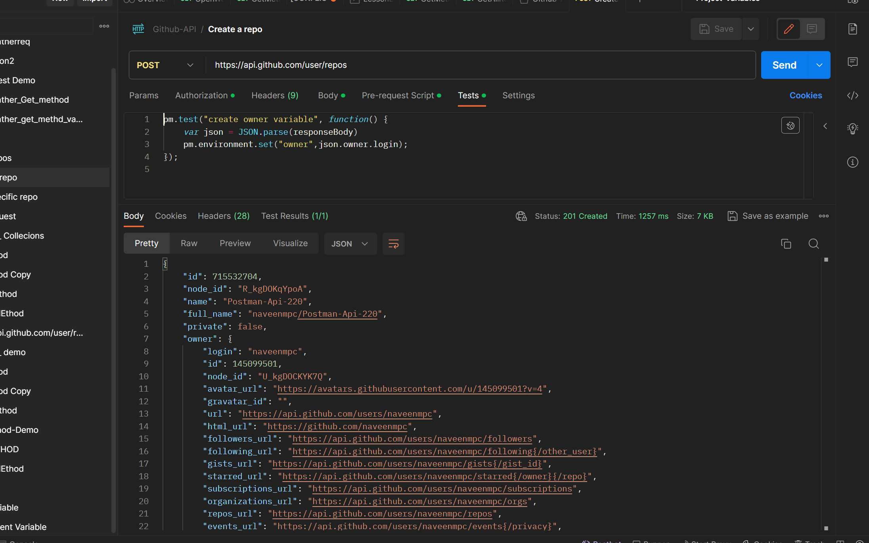

Right Corner we find the dev environment variable. That whish is used to setup for methods in collections.

